Project Design Phase-II
Technology Stack (Architecture & Stack)

Date | 30/09/2026
Team ID | 6ab3d79c6603573ccfb36fe0
Project Name | AI FitTrack
Maximum Marks | 4 Marks

Technical Architecture:
The FitSense Technical Architecture describes how the different components of the system work together to provide AI-based personalized fitness recommendations.
Reference:
Guidelines:
Include all the processes (As an application logic / Technology Block)
Provide infrastructural demarcation (Local / Cloud)
Indicate external interfaces (third party API’s etc.)
Indicate Data Storage components / services
Indicate interface to machine learning models (if applicable)
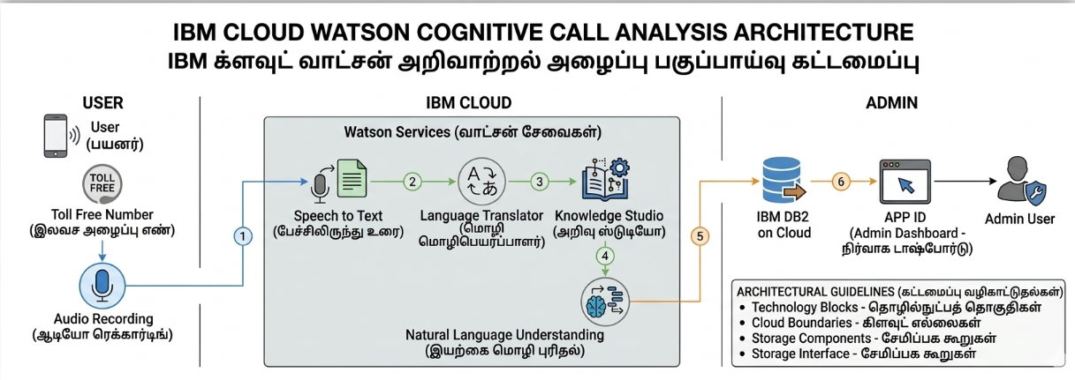

Table-1 : Components & Technologies:

S.No | Component | Description | Technology
 | User Interface | Interface through which users enter fitness details and view recommendations. | HTML, CSS, JavaScript
 | Application Logic-1 | Handles user login, profile, fitness goals, and application functions. | Python, Flask
 | Application Logic-2 | Processes user fitness data and generates personalized recommendations. | Python, AI
 | Application Logic-3 | Handles workout recommendation and fitness-related processing. | Python / AI Model
 | Database | Stores user profiles, fitness goals, activity details, and progress data. | MongoDB
 | Cloud Database | Provides cloud-based storage for application data. | MongoDB Atlas
 | File Storage | Stores required application files and resources. | Local File System / Cloud Storage
 | External API-1 | Provides AI-based processing for generating personalized fitness recommendations. | Gemini API
 | External API-2 | Can be used for additional fitness-related information or services. | Fitness API / REST API
 | Machine Learning Model | Analyzes user information and helps generate personalized fitness recommendations. | AI/ML Recommendation Model
 | Infrastructure (Server / Cloud) | Hosts and runs the FitSense application. | Local Server / Cloud Deployment

Table-2: Application Characteristics:

S.No | Characteristics | Description | Technology
 | Open-Source Frameworks | FitSense uses open-source frameworks for developing the web application and backend services. | Python, Flask, HTML, CSS, JavaScript
 | Security Implementations | User authentication and secure access controls are used to protect user accounts and fitness information. | Password Authentication, Input Validation, HTTPS
 | Scalable Architecture | The system can be expanded to support more users and additional features such as diet recommendations and wearable-device integration. | Flask, REST API, MongoDB Atlas
 | Availability | The application can be deployed on a server or cloud platform so that users can access the system when required. | Cloud Deployment / Web Server
 | Performance | The system is designed to process user fitness information and provide AI-based recommendations with minimum delay. | Python, Flask, MongoDB, AI API

